Q1. Implement an OpenMP program using the parallel for work-sharing construct to perform the addition of two matrices of size M × N. Display the resultant matrix and the Thread ID responsible for computing each row. Compare the execution time of the serial and parallel implementations and comment on the distribution of loop iterations among the threads.
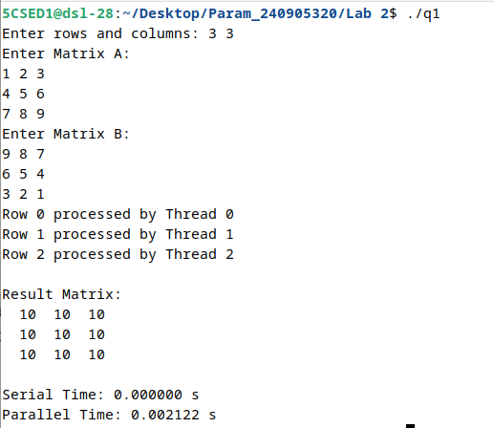
Q2. Implement an OpenMP program to read a matrix A of size 5 × 5 and produce matrix B according to the specified transformation:
- Principal diagonal = 0
- Elements below the diagonal = maximum value of the corresponding row in A
- Elements above the diagonal = minimum value of the corresponding row in A
Display both matrices and indicate the Thread ID responsible for processing each row.

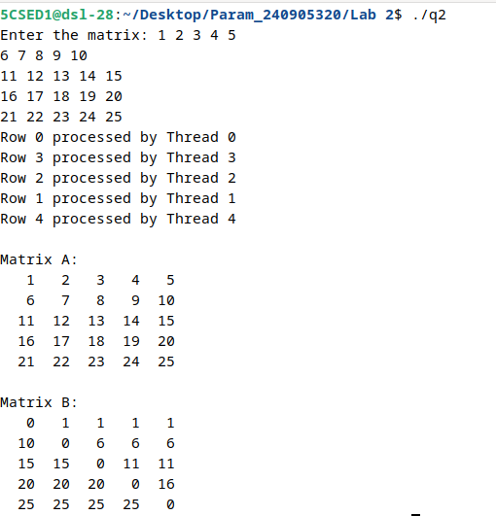
Q3. Implement an OpenMP program that reads a matrix of size M × N and produces:
- Matrix B, where all non-border elements are replaced by their 1's complement.
- Matrix D as specified.
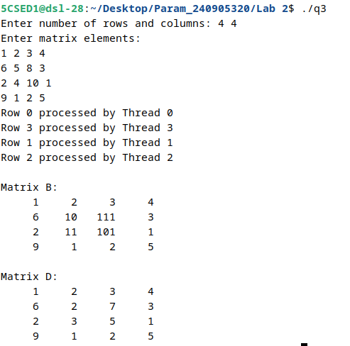
Q4. Implement an OpenMP program to perform matrix-vector multiplication. Record the effect of increasing matrix size on execution time.
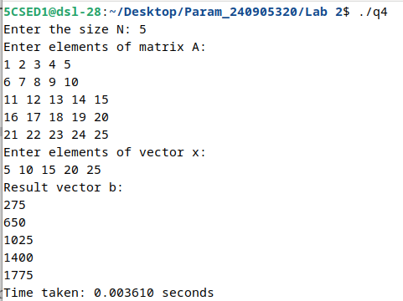
Q5. Implement an OpenMP program to generate an array of random integers using the single construct. Then use the parallel for directive to compute the square of each element. Display the Thread ID that generates the array and the Thread IDs processing the elements.
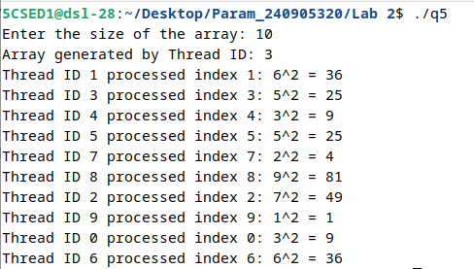
Q6. Implement a parallel program using OpenMP to perform vector addition, subtraction, and multiplication. Demonstrate task-level parallelism. Analyze the speedup and efficiency of the parallelized code.
